**How to access Github api for enterprise?**

Hostname: <https://github-isl-test-01.ca.com/api/v3>text marked in yellow is host url. For Production version it’ll be <https://github-isl-01.ca.com/api/v3>

For any HTTP(s) request add the following headers

**Authorization:** Basic <Your Personal Access Token>

**Content-Type:** application/json

For further details please refer to official documentation on how to access api.

**Accessing Github information**

GET

URL: <https://github-isl-test-01.ca.com/api/v3/app>

Headers:

**Key Value**

Authorization Bearer <access token generated using jwt> [refer [this link](https://developer.github.com/apps/building-github-apps/authenticating-with-github-apps/#authenticating-as-a-github-app) for more details]

Accept application/vnd.github.machine-man-preview+json

**Authenticating as an Installation**

1. GET request to <https://github-isl-test-01.ca.com/api/v3/app/installations>   
   Headers:  
   **Key Value**  
   Authorization Bearer <JWT access token>  
   Accept application/vnd.github.machine-man-preview+json  
     
   This will return the response stating which account(s)/organization(s) have GitHub App installed.  
   Note the ID (Do not use the ID which is seen in nested JSON object. It should be the very first ID you see for an account/organization) value for each account(s)/Organization(s) which will be used in further steps.
2. You need to get access token for specific account(s)/organization(s) using the ID collected in Step 1.  
     
   Make a **POST** request to <https://github-isl-test-01.ca.com/api/v3/installations/5/access_tokens>  
     
   Headers:  
   **Key Value**  
   Authorization Bearer <JWT access token>  
   Accept application/vnd.github.machine-man-preview+json  
     
   After successful POST request you’ll get a response which will be similar to as shown below  
   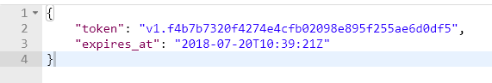  
     
   Token received can be used in further steps.